[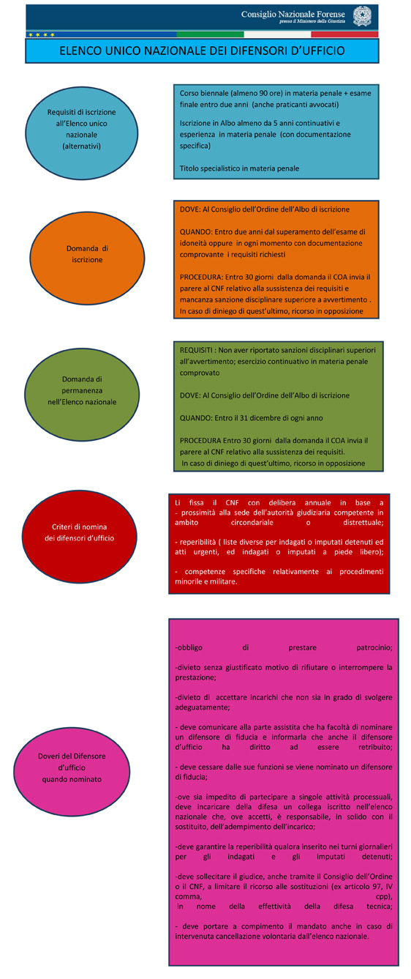](http://ssa-cnf.mncertified.com/nl/link?c=3fj2&d=1d1&h=1f16jnh3kpdcnbe15l87f59mcu&i=1vu&p=H1835612439&s=lp&sn=16e&z=mqh)